# Importing in FT NavVision

## Introduction

Once you are finished with (a part) of the sensorlist, you will at some point need to implement it in NavVision. This is done by importing the sensorlist into NavVision.

In Chapter 9.4 you can see how that is done. Once you have the sensorlist.xls file ready you will put it in the root folder of the NavVision installation. We will go over these steps in the next chapters.

## How to import

Make sure that NavVision is closed and you are in the file explorer. You will have to be in the root folder. Here you will paste the sensorlist.xls file that you just created (see Figure 12‑1).

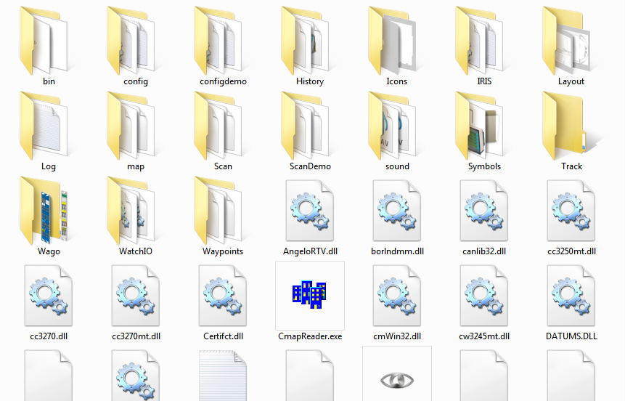

Figure 12‑1: Root folder

Once you have done this, you can start NavVision again. During the startup you will be asked if you want to import the devicelist and/or the sensorlist (this is referring to the 2 tabs in the sensorlist.xls. You answer yes to both the questions (see Figure 12‑2 and Figure 12‑3) and NavVision will continue the startup. At this time the sensorlist will overwrite the existing configuration.

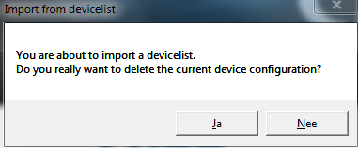

Figure 12‑2: Import devicelist

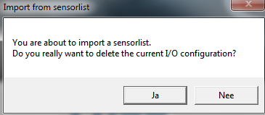

Figure 12‑3: Import sensorlist

Everything you have put into the sensorlist will now be in the configuration of NavVision. This cannot easily be undone, so be very careful if you import. There is a possibility to preserve the old system. Therefor it is necessary that you back up the complete “config” folder. If than anything goes wrong, you can paste the old config folder back.

*: it is always wise to keep a backup of the last working system on for back up sake. Always make a backup of, at least, the “config” folder.*

*Make sure when importing a sensorlist (or even just working on the system) you work on one workstation only (close down all other stations). This way you prevent other workstations from interfering with your setup through the sync-function in NavVision.*

## Check the import

There is not a simple way to check if the import has been successful. The import function has been tested thoroughly by NavVision so the basic import function will work. It is wise to check the import anyway.

As you are probably the one that changed the sensorlist you will now which items has been changed, so you can check these items in NavVision. Also check if the connections are still allright in network>system layout (see ) and if the Wago’s are still in place and connected right, etc. For more information on how to check these items we refer to the

“Installation and commissioning manual”.

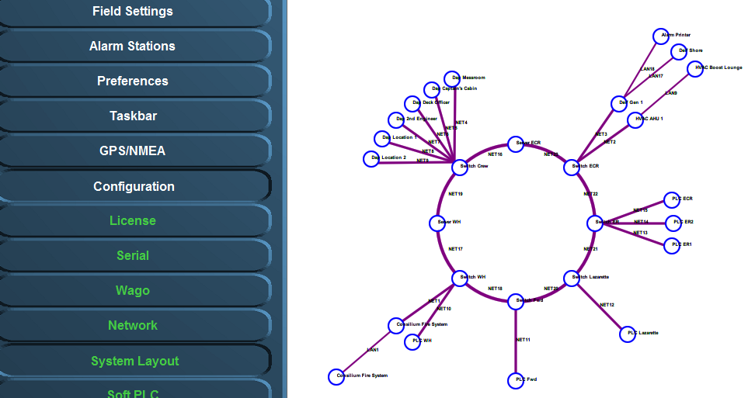

Figure 12‑4: Checking system layout